# CHAPTER 1

# Introduction to Smart Irrigation using Cayenne IoT & AI

## Introduction

Agriculture is the major source of income for the largest population in India and is major contributor to Indian economy. However, technological involvement and its usability has to be grown still and cultivated for agro sector in India. Although few initiatives have also been taken by the Indian Government for providing online and mobile messaging services, web services etc., to farmers related to agricultural queries and agro vendor’s information to farmers. Based on the survey it is observed that agriculture contributes 27% to GDP, and Provides employment to 70% of Indian population,

The term “IoT” stands for the internet of things, can be defined as the interconnection between the individually identifiable embedded computing apparatus in the accessible internet infrastructure. The ‘IoT’ connects various devices and transportations with an help of internet as well as electronic sensors.

IoT is changing the agriculture domain and empowering farmers to fight with the huge difficulties they face. The agriculture must overcome expanding water deficiencies, restricted availability of lands, while meeting the expanding consumption needs of a world population. New innovative IoT applications are addressing these issues and increasing the quality, quantity, sustainability and cost effectiveness of agricultural production.

Agriculture is the backbone of Indian Economy. In today’s world, as we see rapid growth in global population, agriculture becomes more important to meet the needs of the human race. However, agriculture requires irrigation and with every year we have more water consumption than rainfall, it becomes critical for growers to find ways to conserve water while still achieving the highest yield. But in the present era, the farmers have been using irrigation technique through the manual control in which they irrigate the land at the regular interval.

According to statistics, agriculture uses 85\% of available freshwater resources worldwide, and this percentage will continue to be dominant in water consumption because of population growth and increased food demand. There is an urgent need to create strategies based on science and technology for sustainable use of water, including technical, agronomic, managerial and institutional improvements. Agricultural irrigation based on Internet technology is based on crop water requirement rules. By using Internet

technology and sensor network technology we can control water wastage and to maximize the scientific technologies in irrigation methods. Hence it can greatly improve the utilization of water and can increase water productivity.

The Internet of Things (IoT) is a technology where in a mobile device, webapps can be used to monitor the function of a device. The Internet of Things (IoT) is concerned with interconnecting communicating objects that are installed at different locations that are possibly distant from each other Internet of Things (IoT) is a type of network technology, which senses the information from different sensors and makes anything to join the Internet to exchange information.

It can also be used to modify the status of the device. The central processing unit will also include communication device to receive data from the sensors and to be relayed to the user’s device. This will be done using a higher communication device such as a Wi-Fi module. The data processed by the central module is converted to meaningful data and relayed to the user. The user can view the data with the help of a handheld device such as a mobile phone, tablet, laptop etc., Nowadays water scarcity is a big concern for farming. This project helps the farmers to irrigate the farmland in an efficient manner with automated irrigation system based on soil moisture.

The proposed system has been designed to overcome the unnecessary water flow into the agricultural lands. Temperature, moisture and humidity readings are continuously monitored by using temperature, moisture and humidity sensor and send these values to the assigned IP address. Web application continuously collects the data from that assigned IP address. Once the soil moisture values are exceeded the particular limit then the relay, which is connected to the ESp8266 and Arduino microcontroller controls the motor. The web application is a simple menu driven application, with 4 options. This includes valve status, moisture, temperature and humidity values. The motor status indicates the current status of the pump.

Further Data collected from the sensor is used to train AI model to predict which crop is suitable for that land.

## Literature Survey:

Primary investigation is carried out under the following stages, such as Understanding the existing approaches, Understanding the requirements, developing an abstract for the system.

In this paper, soil moisture sensor, temperature and humidity sensors placed in root zone of plant and transmit data to web application. Threshold value of soil moisture sensor that was programmed into a microcontroller to control water quantity. Temperature, humidity and soil moisture values are displayed on the web application.

This paper on "Automatic Irrigation System on Sensing Soil Moisture Content" is intended to create an automated irrigation mechanism which turns the pumping motor ON and OFF on detecting the dampness content of the earth. In this paper only soil moisture value is considered but proposed project provided extension to this existed project by adding temperature and humidity values.

Remote Monitoring in Agricultural Greenhouse Using Wireless Sensor and Short Message Service (SMS). In this paper they are sending data via SMS but proposed system sends the values to mobile application.

This proposed paper is Arduino based remote irrigation system developed for the agricultural plantation, which is placed at the remote location and required water provides for plantation when the humidity of the soil goes below the set-point value. But in this we did not aware about the soil moisture level so to overcome this drawback proposed system included with extra feature soil moisture value and temperature value which displayed on the farmer mobile application.

“Irrigation Control System Using Android and GSM for Efficient Use of Water and Power” this system made use of GSM to control the system which may cost more so to overcome that proposed system used Arduino Yun board which already consist of in build wife module.

“Microcontroller based Controlled Irrigation System for Plantation” In this paper old generation with lesser memory microcontroller is used to control the system but proposed system made use of Arduino Yun board which is user friendly and it helps to dump the programs easily.

“A wireless application of drip irrigation automation supported by soil moisture sensors” in this paper irrigation is carried out using soil moisture values but extend to this proposed system displays temperature and humidity values.

By referring all above papers, it is found that no such systems are existed with all integrated features but proposed system includes these all features such as displaying temperature, humidity and soil moisture values and also automatic switching on and off of motor by considering soil moisture values.

# CHAPTER 2

# System Design

## Hardware requirements:

* NodeMCU /ESP8266
* Arduino UNO
* 5-VRelay
* Jumpers
* Soil moisture sensor
* Flame sensor
* RainDrop Sensor
* DHT11
* Solenoid valve
* Buzzer
* Breadboard
* Centrifugal aquarium pump
* Power Regulator

### NodeMCU /ESP8266

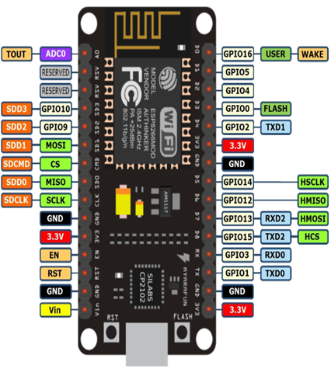

**NodeMCU** is an open source IOT platform. Basically, the Node MCU uses Lua scripting language to program. Arduino IDE also can be used to program NodeMCU. node MCU runs an ESP8266 WIFI soC from Espressif systems. Node MCU has a built in WIFI module. That means you can easily connect it to Wi-Fi few lines of codes. NodeMCU has 4mb of storage and 128 kb of memory. It has several GPIO (general purpose input output) pins for device connectivity. It has only one Analog pin for Analog input.

### Arduino Uno:

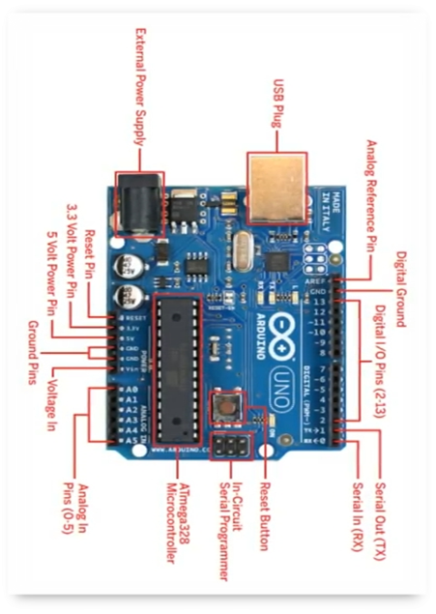

* Arduino is microcontroller based opensource electronic prototyping board which can be programmed with an easy-to-use Arduino IDE
* Arduino consists of both a physical programming circuit board and a piece of software.

### 5V-Relay:

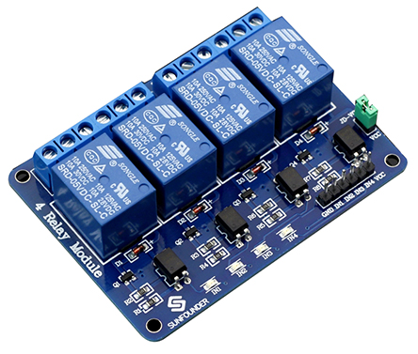

**5V 4-channel relay** interface board, and each channel needs a 15-20mA driver current. It can be used to control various appliances and equipment with large current. It is equipped with high-current relays that work under AC250V 10A or DC30V 10A. It has a standard interface that can be controlled directly by microcontroller.

### Jumpers:

### 

A **jump wire** (also known as jumper, jumper wire, **j**umper cable, DuPont wire or cable) is an electrical wire, or group of them in a cable, with a connector or pin at each end (or sometimes without them – simply "tinned"), which is normally used to interconnect the components of a breadboard or other prototype or test.

### SoilMoisture Sensor:

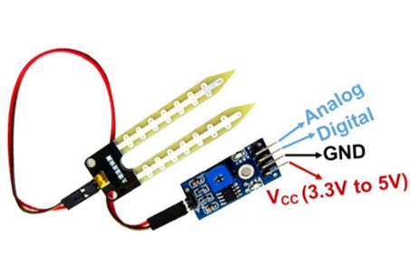

**Soil moisture sensor** measure the volumetric water content in soil. It consists of 4 pins i.e., VCC, GND, DO, AO. digital out is connected to the output pin of LM393 comparator IC while the analogue pin is connected to moisture sensor.

Connect VCC and GND pins to 5v and GND pins of microcontroller. After that insert the probe inside the soil.

### Flame sensor:

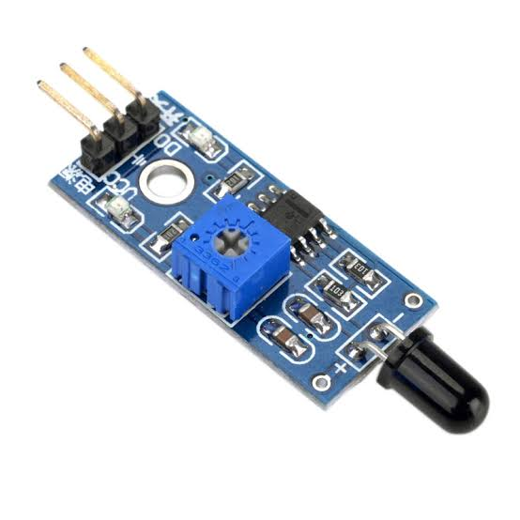

A flame-sensor is one kind of detector which is mainly designed for detecting as well as responding to the occurrence of a fire or flame. The flame detection response can depend on its fitting. It includes an alarm system, a natural gas line, propane & a fire suppression system. This sensor is used in industrial boilers. The main function of this is to give authentication whether the boiler is properly working or not. The response of these sensors is faster as well as more accurate compare with a heat/smoke detector because of its mechanism while detecting the flame.

### RainDrop Sensor:

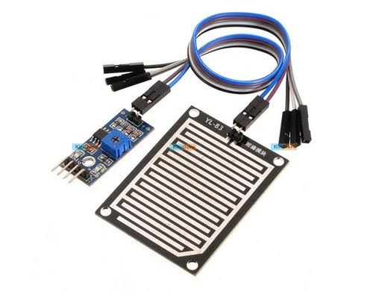

**Raindrop sensor** is basically a board on which nickel is coated in the form of lines .it works on the principal of resistance. Rain drop sensor module allows to measure moisture via analogue output pins and it provides a digital output when a threshold of moisture exceeds.

### DHT11:

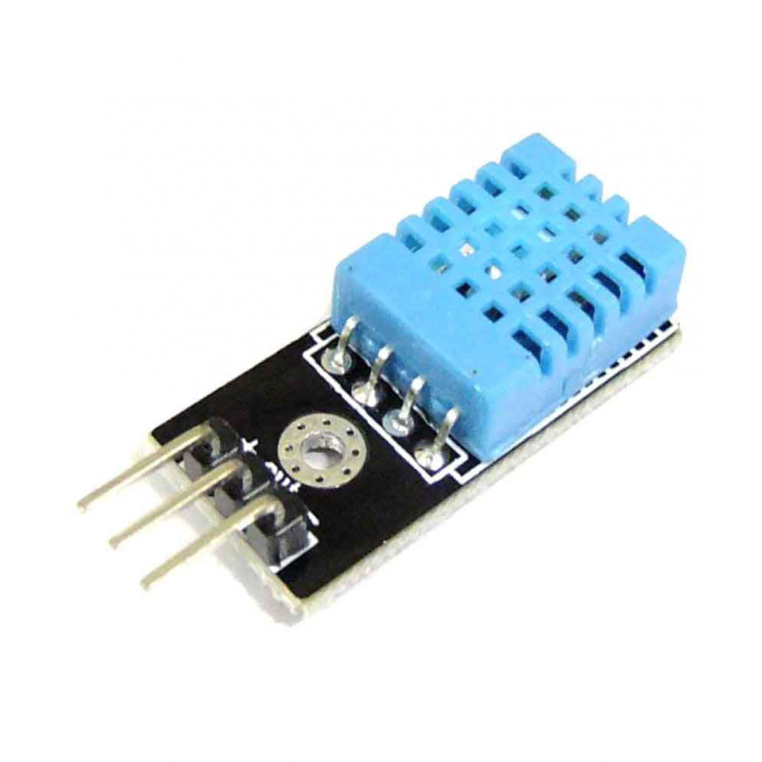

DHT11 Temperature & Humidity Sensor features a temperature & humidity sensor complex with a calibrated digital signal output. By using the exclusive digital-signal-acquisition technique and temperature & humidity sensing technology, it ensures high reliability and excellent long-term stability. This sensor includes a resistive-type humidity measurement component and an NTC temperature measurement component, and connects to a high-performance 8-bit microcontroller, offering excellent quality, fast response, anti-interference ability and cost-effectiveness.

### Solenoid Valve:

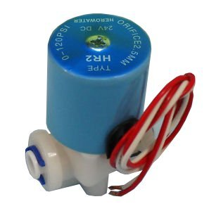

A **solenoid valve**, otherwise known as an electrically-operated valve is an automatic valve which serves the purpose of removing the need for an engineer to operate a valve manually. Solenoids operate using an electromagnetic solenoid coil to change the state of a valve from open to closed, or vice-versa.

### Buzzer:

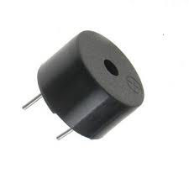

A buzzer or beeper is an audio signalling device which may be mechanical, electromechanical, or piezoelectric (piezo for short). Typical uses of buzzers and beepers include alarm devices, timers, and confirmation of user input such as a mouse click or keystroke.

### Breadboard:

**A Breadboard** is a rectangular plastic board with many mounting holes. The holes let you insert electronic components to prototype an electronic circuits .They are used for creating electrical connections between electronic components and single board computer or microcontroller such as Arduino and Raspberry pi. It is made up of three sections two sets of very long power rails and the large middle section that is full of those 5 holes-long terminal strips.

### Centrifugal Pump:

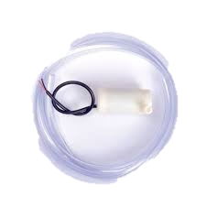

A **centrifugal pump** operates through the transfer of rotational energy from one or more driven rotors, called impellers. The action of the impeller increases the fluid's velocity and pressure and directs it towards the **pump** outlet. This pump works on basic principle of change in angular momentum. It states that the change in the angular momentum of a rotating particle is equal to the applied force. It means when a certain amount of liquid is rotated with the help of external agency means turbines or electric motor or external force, a centrifugal force acts on it which further turns into pressure.

### Power Regulator:

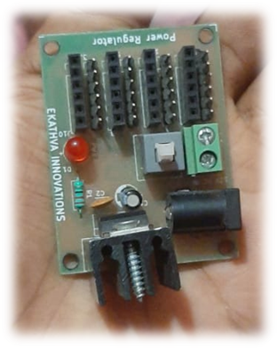

A **power regulator** is such a device that maintains constant output voltage, instead of any kind of fluctuations in the input voltage being applied or any variations in current, drawn by the load.

This device is used to get different voltage supply from single device in this project.

## Software Requirements:

* Arduino IDE
* Fritzing
* Tinkercad Web App
* myDevices Cayenne Web App
* Git
* GitHub

### Arduino IDE

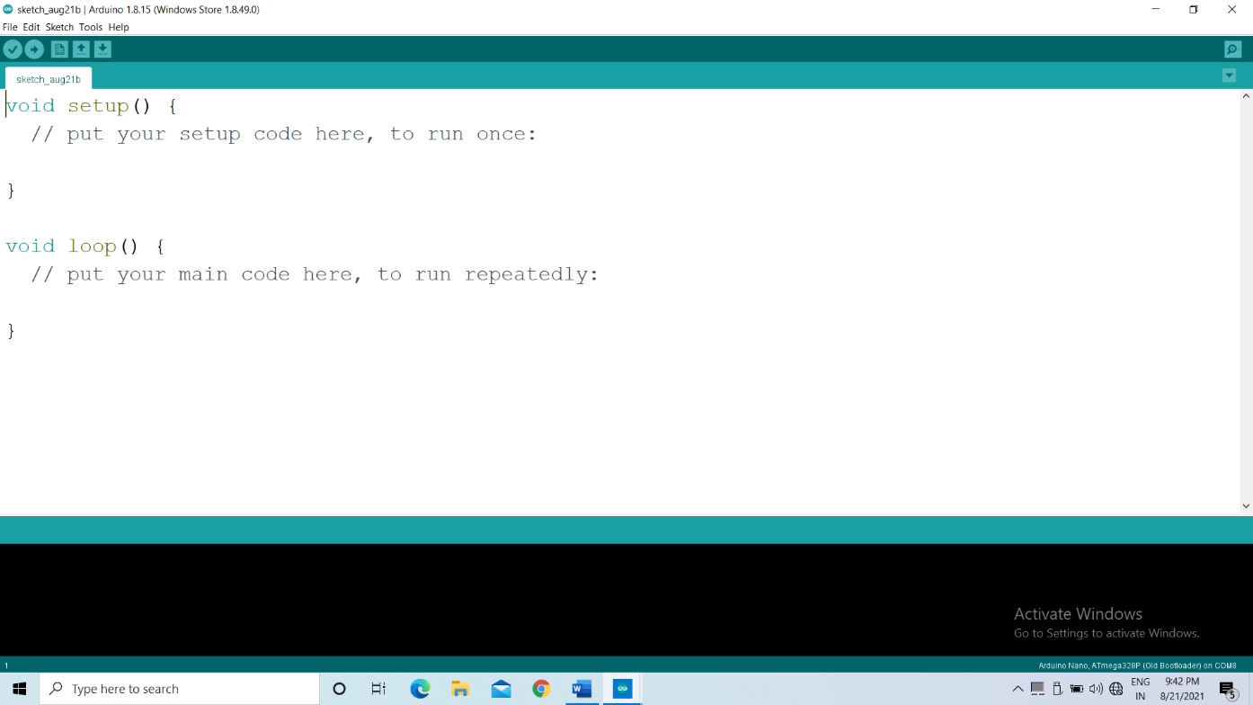

The Arduino Integrated Development Environment (IDE) is a cross-platform application (for Windows, macOS, Linux) that is written in functions from C and C++.t is used to write and upload programs to Arduino compatible boards, but also, with the help of third-party cores, other vendor development boards.

### Fritzing:

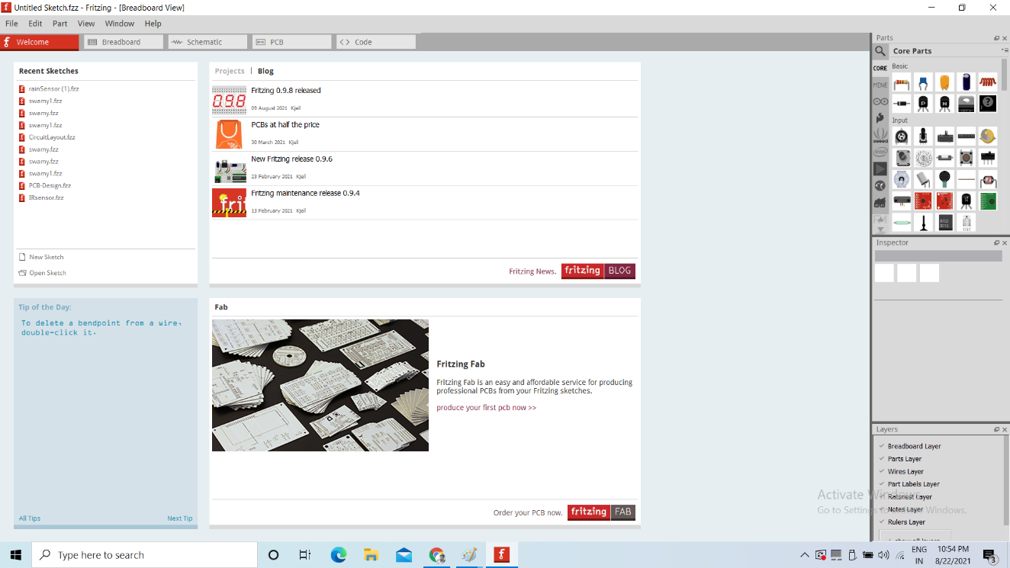

Fritzing is an open-source initiative to develop amateur or hobby CAD software for the design of electronics hardware, to support designers and artists ready to move from experimenting with a prototype to building a more permanent circuit. It was developed at the University of Applied Sciences Potsdam Fritzing is free software under the GPL-3. or-later license, with the source code available gratis on GitHub and the binaries at a monetary cost, which is allowed by the GPL.

### Tinkercad Webapp:

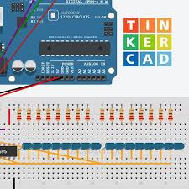

**Tinkercad web app** use to design 3-D model and simulation of microcontroller /development board such as Arduino, NodeMCU etc.,

### Git:

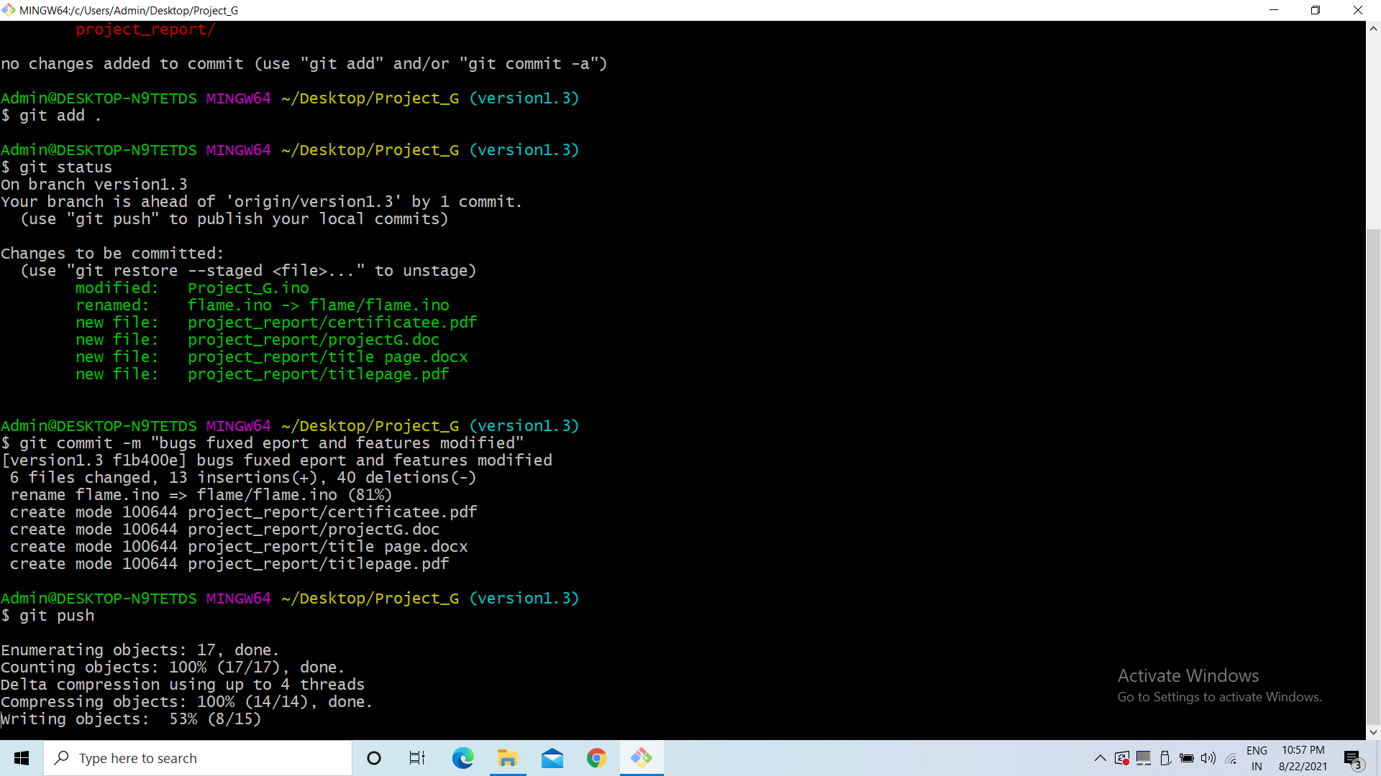

Git is a free and open-source distributed version control system designed to handle everything from small to very large projects with speed and efficiency.

Git is software for tracking changes in any set of files, usually used for coordinating work among programmers collaboratively developing source code during software development. Its goals include speed, data integrity, and support for distributed, non-linear workflows (thousands of parallel branches running on different systems).

### GitHub:

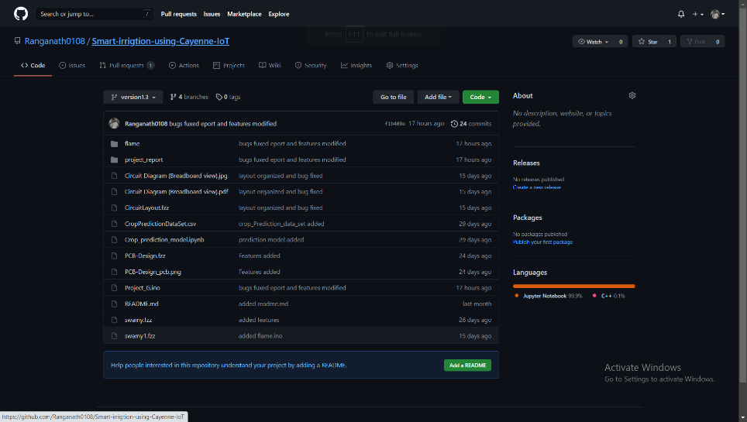

GitHub, Inc. is a provider of Internet hosting for software development and version control using Git. It offers the distributed version control and source code management (SCM) functionality of Git, plus its own features. It provides access control and several collaboration features such as bug tracking, feature requests, task management, continuous integration and wikis for every project. Headquartered in California, it has been a subsidiary of Microsoft since 2018.

### Block Diagrams:

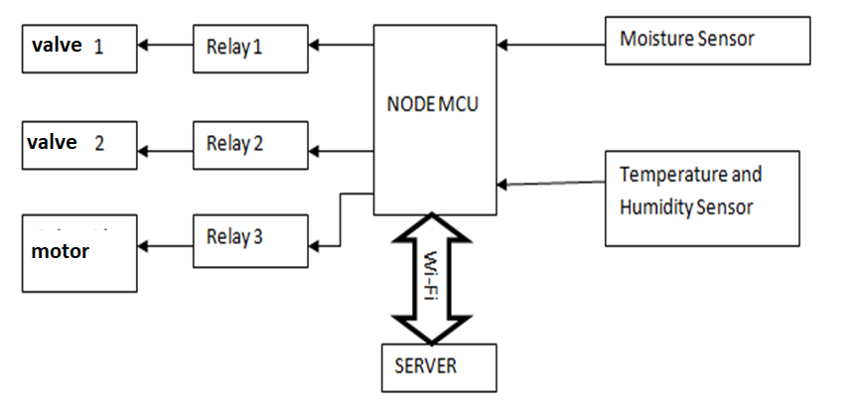

Fig. Block diagram of Stage 1

In Stage1 NodeMCU communicates with myDevices Cayenne Server by using API. The sensed data from the sensor is pushed to cayenne server and an appropriate actuator action take place based on the written program.

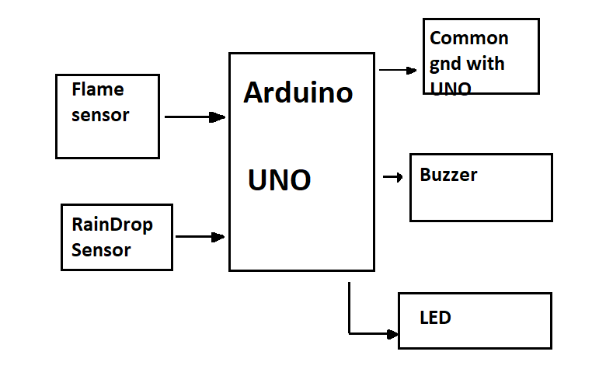

Fig. Block Diagram of Stage2

* The major purpose of using the Arduino UNO for fire alarm the response time of Arduino Uno is faster than NodeMCU.
* Another purpose of NodeMCU is for 5v power supply, as we know NodeMCU max output voltage is 3.3v, to trigger the relay and to power the relay 5v power supply is essential.

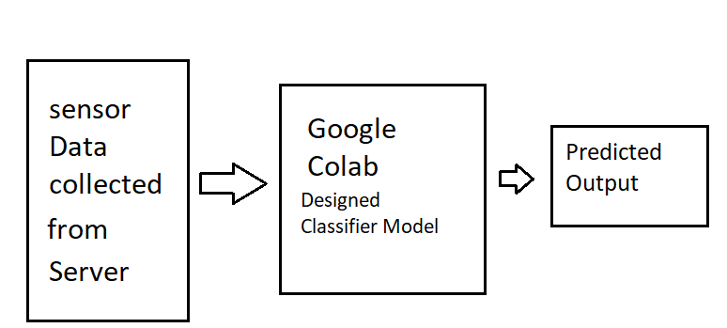

Fig. Block diagram of Stage3

In this stage the data collected in the Cayenne server is used, In collab a AI classification model is created, by using the data collected from the cayenne it will predict which crop which is suitable for the land.

## Circuit Diagram:

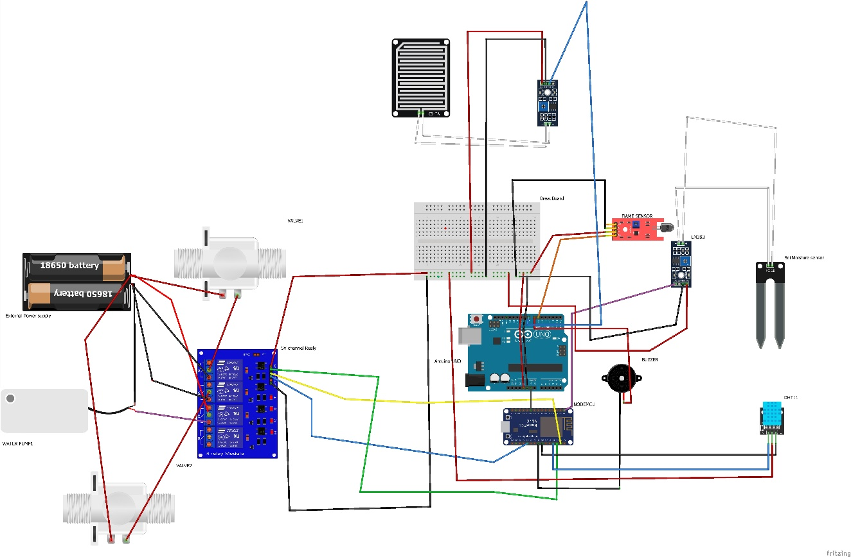

## PCB Layout:

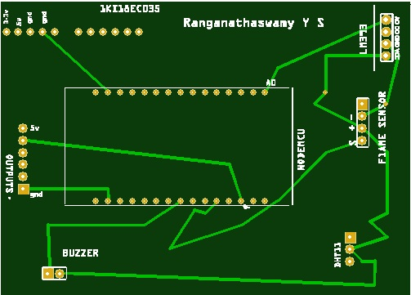

Fig: Top View of PCB

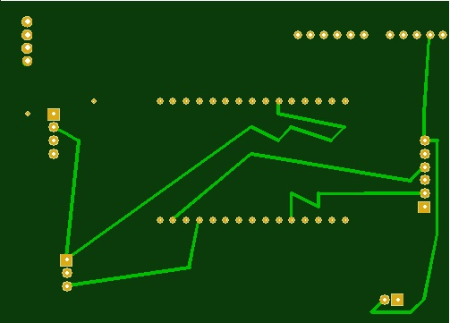

Fig. Bottom View of PCB

# CHAPTER 3

# Algorithm

## 3.1 Algorithm for server side (NodeMCU):

